|  |
| --- |
|  |
| Labs of Rynth |
| Final Report  GitHub: <https://github.com/micle546/LabsOfRynth>  Issues and Tasks: <https://github.com/users/micle546/projects/9> |

|  |
| --- |
| Mike Eubank (meubank); Chris Coggins (ccoggins)  12-17-2022 |

## Project Overview

We have developed the beginnings of a maze/puzzle game, where the player must navigate the maze and avoid enemies in the process. Our goal was to create a first-person maze/puzzle game with power ups (speed boosts, path tracking, puzzle tools, etc), sub objectives (collectables, maybe enemies, or things to catch), and hazards/traps. Sci-fi themed 3d first person with interactable objects that affect doors, walls, or other aspects of the level.

Win conditions: Reach the yellow cube at the end of the level and press “e” to interact with it.

Failure conditions: Health reaches 0

Enemies: Will chase the player indefinitely. can be trapped behind doors, will damage player on contact.

* Bug: only follow player when looked at directly, should follow if player is visible.

1. Core mechanics
   1. Maze navigation
   2. ~~Maze generation~~
   3. ~~Puzzle solving~~ 
      1. ~~Lock and key~~
      2. ~~Hazard avoidance~~
      3. ~~Switches~~
      4. ~~Portals~~
   4. Pursuing enemies
2. Visual aesthetic
   1. Sci-Fi Lab corridors
3. User Interface
   1. First Person
4. Controls - WASD movement - Mouse (Pan & tilt)
5. Target audience - Humans!

Future work

1. User Interface
   1. Shows equipment Icons (if any)
2. Music/atmosphere - (look at snapmuse for potential music) - <https://incompetech.com/music>

## Project tasks

Please see the following links for an up-to-date status of the current project

Mike – Micle546, Chris – Coggs92

Project tasks categories: <https://github.com/users/micle546/projects/9/>

Iteration Overview: <https://github.com/users/micle546/projects/9/views/4/>

## Project Tasks

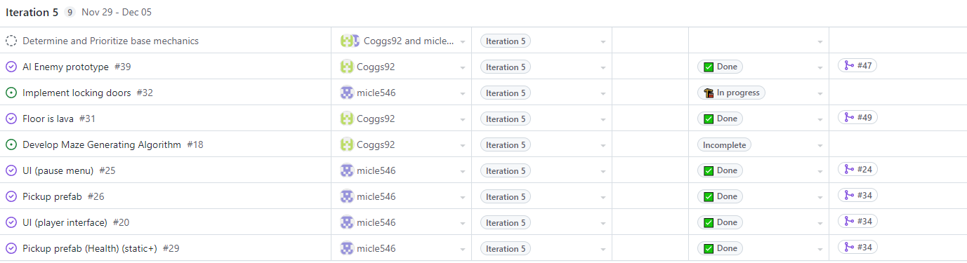

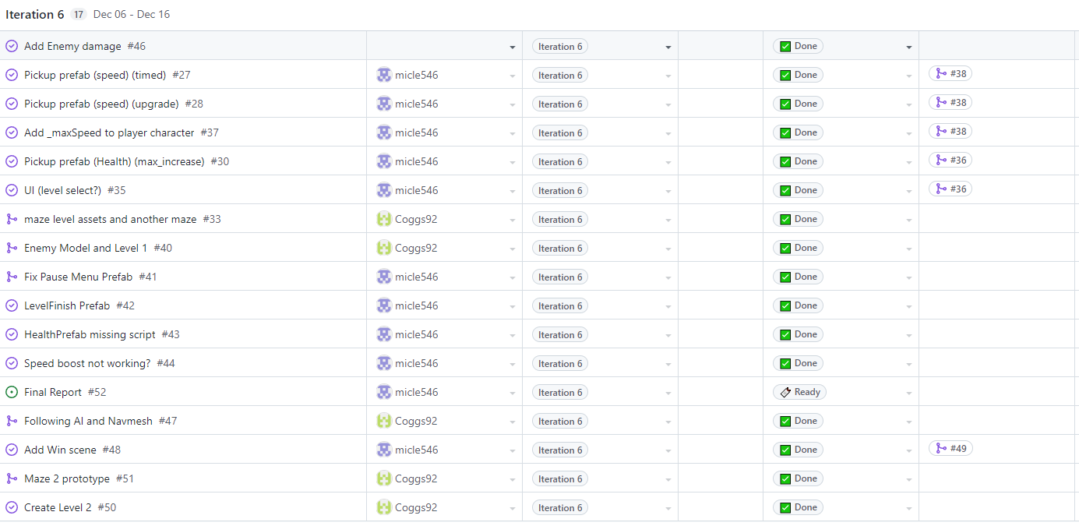

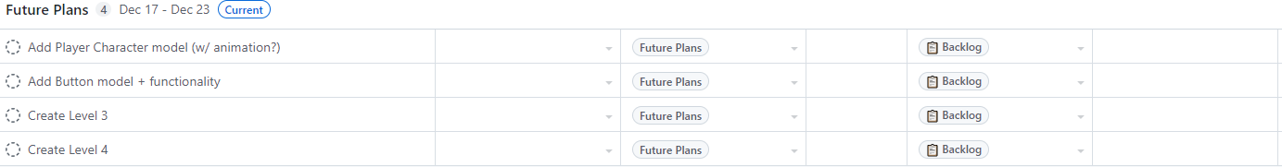

## What I learned

I’ve learned that time management is a very critical skill to learn, especially when distracted by other projects of equal importance. In game development, I was unaware how little time is spent actually coding, and how most of the time spent is in building assets, and refining mechanics. Having a solid understanding of how the different systems interact with each other plays a really important role in the game development process. I imagine that’s what the upper management of a gamedev team spends so much time doing, directing the creative vision of the project to form a cohesive whole.

## Conclusion

We have the basics of a game built, with what little time we were able to commit to this project. Were we able to continue on this project, we would add more levels to the game to lengthen the experience, potentially spreading out new features over time, like the speed boosts, the unadded buttons, switches, and locked doors. We would also like to complete the health system. I would have liked to have an animated player model added into the game too, instead of just the basic capsule.